**Section 2: Childhood and Family Life of Prince Siddhartha**

In this section we are going to see the childhood and young days of Prince Siddhartha (lay life of the Gotama Buddha) and his family and some of important events connected to this period.

**▲ Prince Siddhartha’s Parents**

He was named Siddhartha meaning “**he who achieves his goal” [1]** . According to the scriptures, Prince Siddhartha, the future Buddha, was born to the Sakyan clan from Kapilavattu. His father was King Suddhodana and his mother was Queen Mahamaya. [2] Following his mother’s death, seven days after his birth [3], Queen Maya’s sister, Queen Prajapati (also a Queen consort to King Suddhodana) became the prince’s foster mother [4] Prince Siddhartha had a half-brother, Prince Nanda and a half-sister, Princess Nandā, who were children of King Suddhodana and Queen Prajapati. Queen Prajapati is remembered throughout history as she later became the first Bhikkhuni in what was to be the Buddha’s community of nuns.

♦ References to the Buddha’s family can be found in the Suttas, few extracts are listed below.

**In Mahâpadāna Sutta (DN:14)** includes a passage where the Devas mention the parents of the Buddha:

*“…in this fortunate aeon now, the Lord Buddha has arisen in the world… his father is King Suddhodana, his mother was Queen Maya, and his royal capital is Kapilavattu…”*

**♦ In the same sutta, the Buddha elaborated:**

*“…and now, monks, my father was King Suddhodana, my mother was Queen Maya, and the royal capital was Kapilavattu…”[5]*

**♦ In the Udana, Ven Ānanda Thera** refers to Queen Maya’s passing away seven days after the Buddha’s birth:

*“…it’s incredible, sir, it’s amazing! How short-lived was the Blessed One’s mother!*

*For seven days after the Blessed One was born, his mother passed away and was reborn in*

*the host of joyful gods (Tusita heaven) ...”*

**The Buddha responds**:

“*That’s so true, Ānanda! For the mothers of beings’ intent of awakening are short-*

*lived. Seven days after the being’s intent on awakening are born, their mothers pass away*

*and are reborn in the host of joyful gods…”* [6]

**♦ Ven Kāludāyi Thera** [7] a disciple of the Buddha said this:

*“…Suddhodana is the name of the Great Seer’s father, and Māyā name of the Buddha’s mother who, having nurtured the bodhisatta with her womb, at the break-up of the body, rejoices in the threefold divine realm. She, Gotamī, having passed away, having fallen away from here, is now endowed with heavenly sensual pleasures…”* [8]

**♦ In Dakkhiṇāvibhanga Sutta** (MN:142) the flowing extract also confirmed that Queen Mahapajapati was the foster mother of the Buddha. In this sutta Venerable Ãnanda said:

*“… Mahāpajāpatī Gotamī has been very helpful to the Blessed One, venerable sir. As his mother’s sister, she was his nurse, his foster mother, the one who gave him milk. She suckled the Blessed One when his own mother died…”*

**♦ Queen Prajapati,** refers to her role as the Buddha’s foster mother:[9]

*“…Sublime One, I am your foster mother, but you gave me the milk of the True Dhamma, therefore you are my Father… Greatest Hero, I have raised you by nursing you...and You are the One who supported me to build this Dhamma body. I quenched your thirst with my breast milk, the Dhamma milk given by you extinguished my worldly desires. The positions of ‘King’s mother’…’Kings wife’; are worthy titles for women, but the title of “Buddha’s mother” is more great, more novel, grander…!”[10]*

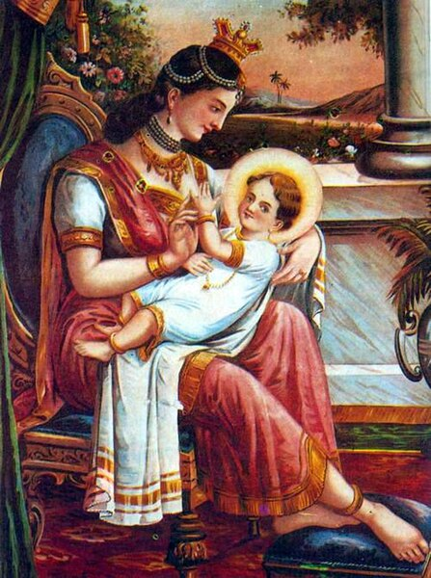

**Prince Siddhartha (Gotama Buddha) with Maha Pajapati Gotami—Foster mother**

**Picture Courtesy:** https://commons.wikimedia.org/wiki/File:

**▲ Prince Siddhartha’s Childhood**

Prince Siddhartha grew up in princely luxury, shielded from the outside world. Two important and unusual “spiritual” events, a precursor to the path that he would subsequently follow, are documented in the scriptures.

♦ **Prophesy about Buddhahood**

The first event occurred when a famous ascetic, Asita (also called Kāladevala), visited King Suddhodana, to see the new born prince. The ascetic prophesied that the baby prince would be a spiritual leader [11].

*“…he is supreme, the best of men!... this boy shall reach the highest awakening.*

*As one of perfectly purified vision, compassionate, for the welfare of the many, he shall roll*

*forth the wheel of the teaching; his spiritual path will become widespread…”* [12]

**The prophecy of the seer Asita** : Source- Pakistan, Gandhara region, 3rd/4th century; slate Museum Rietberg, Zurich; Inv. No. RVI 11 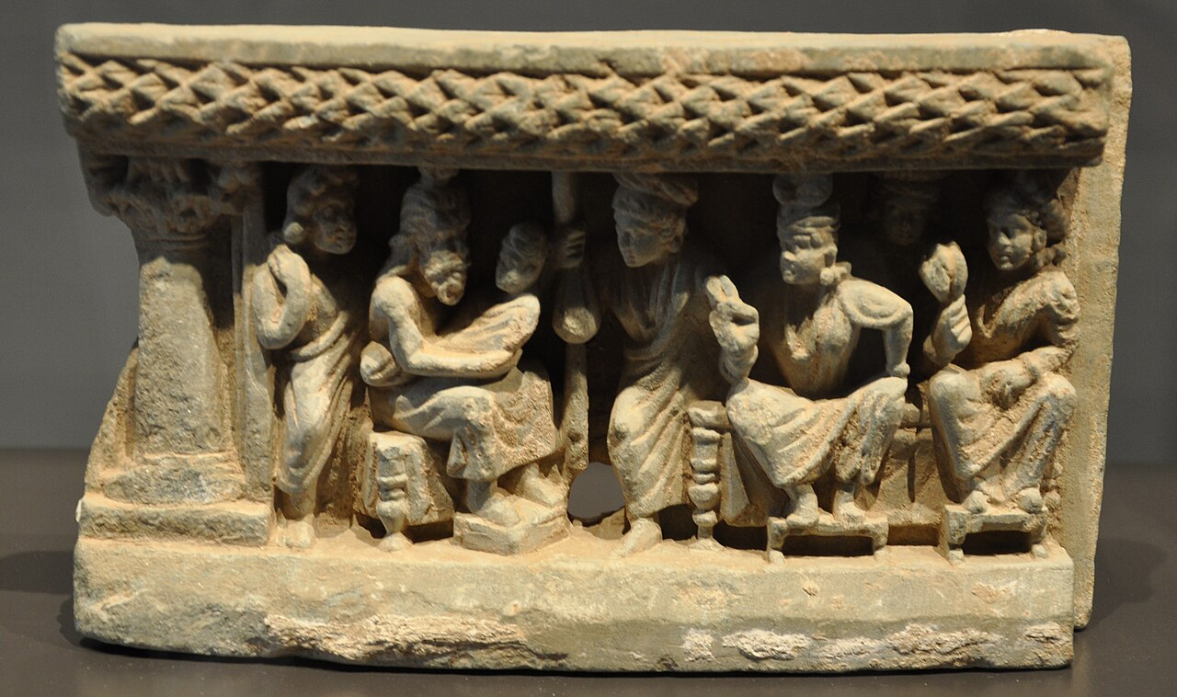(public domain). Picture courtesy: https://en.wikipedia.org/wiki/Asita

♦ **Meditative attainment as a child**

The second event was at a ploughing festival presided over by his father; when Prince Siddhartha was found meditating under a Rose Apple tree, supposedly entering the first Jhana. After becoming the Buddha, the Blessed One recalled that incident thus:

*“…I recall that when my father the Sakyan was occupied, while I was sitting in the cool shade of a rose- apple tree, quite secluded from sensual pleasures, secluded from unwholesome states, I entered upon and abided in the first jhāna, which is accompanied by applied and sustained thought, with rapture and pleasure born of seclusion…*’ [13]

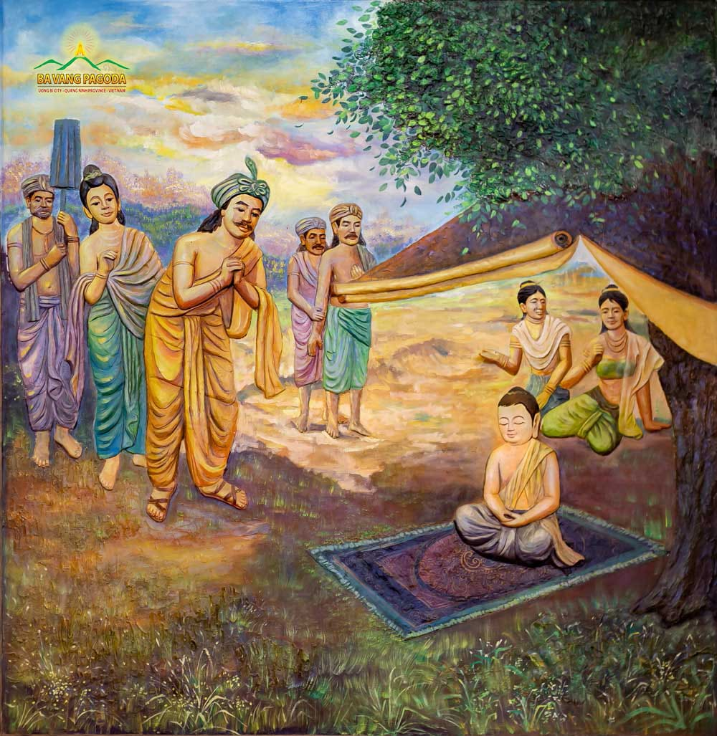

**Prince Siddhartha meditated during the Ploughing Festival.** Picture courtesy: **Thay Thich Truc Thai Minh** ttps://en.thaythichtructhaiminh.com/

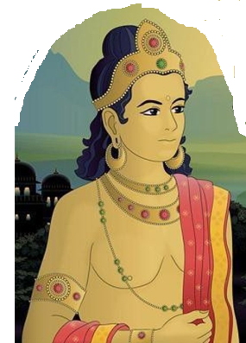

**Young Prince Siddhartha**: Source: Story of Buddha by Gyasto Geshe Kelsang.

https://tharpa.com/

**▲ Young Prince Siddhartha**

According to the scriptures, prince Siddhartha lived in the royal palace in Kapilavattu, the capital of the Sakyan Clan until the age of 29. The Buddha recalls:

“*I lived in lay life for twenty-nine years… Bhadda Kacchana*

*(Yashodhara) was may queen… Rahula was my son’* [14]

♦ **In this sutta the Buddha describes his princely life:**

*“…I was delicately nurtured…at my father’s residence lotus ponds were made just for my enjoyment: in one of them blue lotuses bloomed, in another red lotuses, and in a third white lotuses… I used no sandalwood unless it came from Kāsi and my headdress, jacket, lower garment, and upper garment were made of cloth from Kāsi … I had three mansions: one for the winter, one for the summer, and one for the rainy season… I spent the four months of the rains in the rainy-season mansion, being entertained by musicians, none of whom were male and I did not leave the mansion…”* [15]

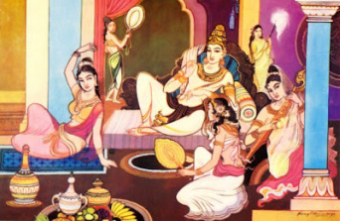

**Royal life of Prince Siddhartha**

Source: The Buddha and Buddhism

https://explorebuddhism.weebly.com/royal-life.htm

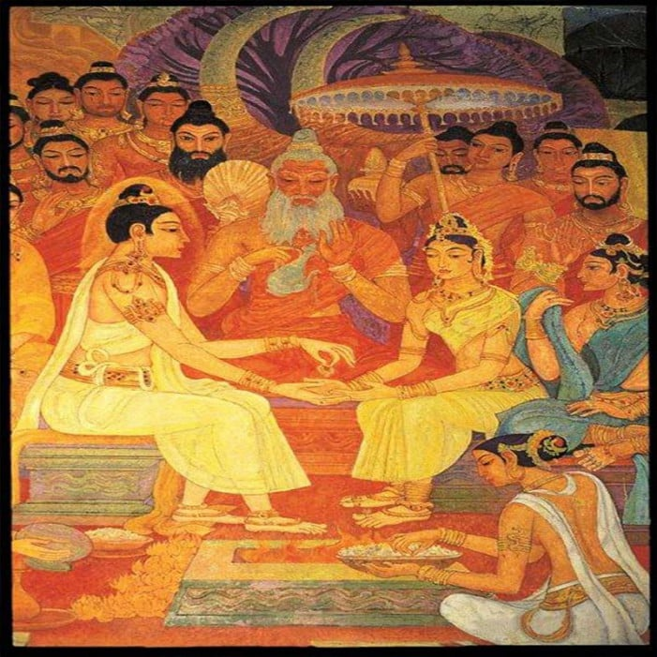

**Royal wedding of Prince Siddhartha and princess Yasodhara** by Sri Lankan Artist Somabandu Vidhyapathy -A wall painting at Bellanvila Rajamaha Vihara, Sri Lanka. Picture courtesy: https://www.tumblr.com/

**Note:**

In our next section (3) we will describe the story of Prince Siddhartha's departure from the palace at the age of 29 and becoming an ascetic, followed by his Buddhahood at the age of 35. Since at this point we are describing the family of the Buddha, we thought it is appropriate to mention how the Buddha, after attaining enlightenment, guided his parents and close family members to develop spiritual life to end the suffering of samsara. The relevant details are given below.

**▲Princess Yasodharā**

According to legends, Princess Yasodharā (Bhaddā Kaccānā) was married to Prince Siddhartha when they were both aged sixteen [16]. Princess Yasodharā’s father was King Suppabuddha of the Koliya clan of Devadaha city and her mother was Amita Devi (sister of King Suddhodana). They had a son, Rāhula. Yasodharā later ordained as a bhikkhuni and attained full Enlightenment. The Buddha declared her as the foremost bhikkhuni to have attained great direct knowledge [17].

♦ When Yasodharā Theri was 78 years old, before her Parinibbāna, her final passing, she paid her respect to the Blessed One and said this:

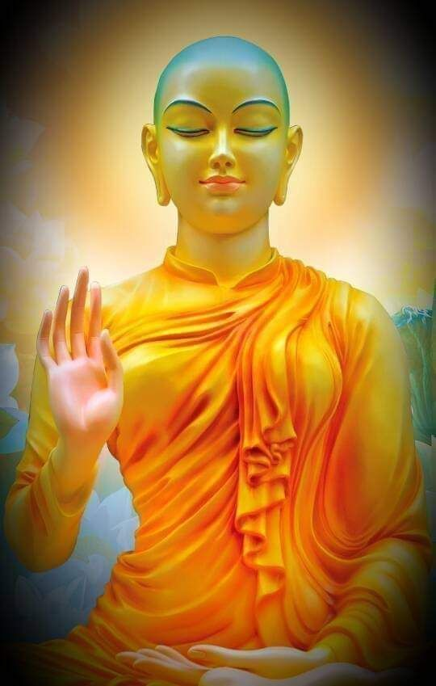*“…Iam Yasodharā, Hero; in the home I was your chief queen, born in the clan of the Śākyas, established among the women in your household, O Hero, I was the leader, the lord of all of the women there … “I am Yasodharā, Hero; I worship your feet, Eyeful One…”* [18]

**Arahant Bhikkhuni Yasodharā** : Picture courtesy:Pinterest

https://in.pinterest.com/pin

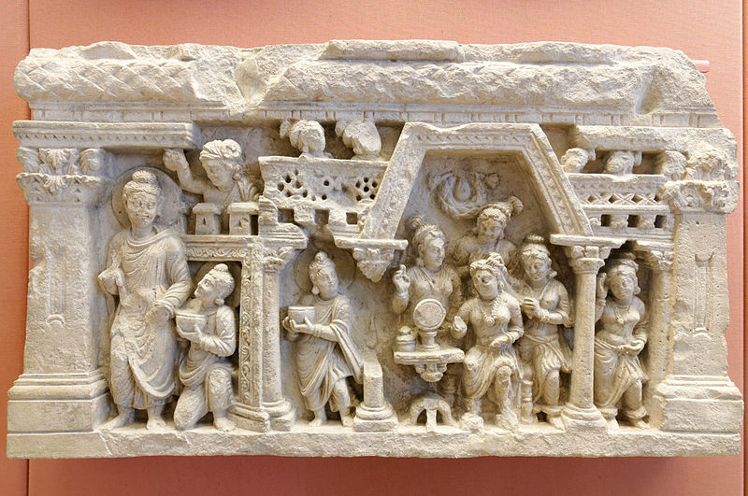

**Above:**  **Prince Nanda following the Blessed One-** though he was carrying the bowl of the Buddha his mind was on his wife to be ‘Janapada Kalyani’ who was standing in the balcony: picture courtesy: Wikimedia Commons (Gandhara Art)

**▲Prince Nanda**

Nanda Gotama was the half-brother of the Buddha. His parents were King Suddhodana and Queen Prajapati. At one time, after his Enlightenment, the Blessed One on invitation by his father, visited Kapilavattu. At that time, Prince Nanda was to marry a beautiful Sakyan maiden known as ‘Janapada Kalyani’ (meaning the most beautiful maiden of the province). After taking his meal at his father’s palace, the Buddha gave his alms bowl to Prince Nanda and walked with him to the monastery. When the Bleared One asked Prince Nanda whether he would like to become a monk, out of respect to the Buddha, Nanda consented, although his thoughts were still of his lay life and his former bride to be. Nanda wanted to return to his former life as a royal prince. When the Blessed One came to know of his intention, using his spiritual powers, he transported Nanda into the Tavatimsa Deva realm where there were many beautiful deva maidens. Showing them to Nanda, the Blessed One said: [19]

*“…Rejoice, Nanda, rejoice! I guarantee you five hundred dove-footed nymphs.”*

Nanda responded:

*“If, sir, you guarantee me five hundred dove-footed nymphs, I shall happily lead the spiritual life under the Buddha.”* [20]

When his fellow monks came to know that the bhikkhu Nanda was leading his spiritual life to gain access to divine maidens, they mocked him and laughed at him.

*“…then Nanda—embarrassed, ashamed…. living alone, withdrawn, diligent, keen, and resolute, soon realised the supreme end of the spiritual path in this very life…Venerable Nanda became one of the perfected…”[21]*

The Buddha declared that among the Bhikkhu Sangha of those who guard the doors of the

sense faculties Nanda was the foremost [22]

In his Thera Gatha, the noble Nanda Thera said thus:

*“…because of focusing on the wrong things,*

*I was addicted to ornamentation.*

*I was vain…desire for pleasures of the senses.*

*But with the help of the Buddha,*

*the kinsman of the Sun, so skilled in means,*

*I practiced rationally and extracted attachment*

*to continued existence from my mind…”* [23]

In his Apadana, Nanda Thero mentioned that in one of his former births he

worshipped the Buddha Padumuttara and this is what the Buddha said about his future life:

*“…after spending heavenly and human pleasures, due to good kamma, you will be born as a younger brother of Buddha Gotama… attached to sensual pleasures you will be guided by the Blessed One, …will be peaceful and attain to arahathood”* [24]

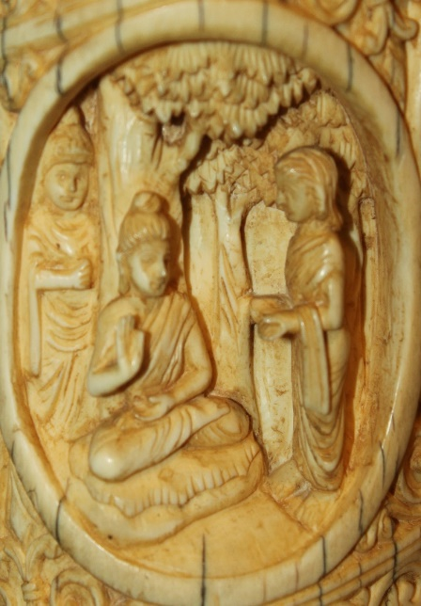**▲Princess Nandā Gotami**

Like prince Nanda, princess Nandā’s parents were King Suddhodana and Queen Prajapati, hence she was the half-sister of the Buddha. Tradition says that she was beautiful and so was called Sundarī Nandā (beautiful Nandā). When her mother Queen Prajapati, renounced lay life and became the first Bhikkhuni, out of respect for her, princess Nandā also became a nun. In the beginning, Nandaā Theri, thinking about her appearance, neglected her Dhamma training. It was when the Buddha pointed out the impermanence of beauty, realising this truth, she became fully enlightened. The Blessed One declared that among bhikkhuni meditators Nandā Theri was foremost [25]

**The Buddha advising Nandā Theri**. Picture courtesy: Wikipedia https://en.wikipedia.org/wiki/Sundari_Nanda

* In Theri Gatha of Venarable Nandā stated how the Buddha regularly advised her with these verses:

*“…Nandā, see this bag of bones as diseased, filthy, and rotten. With mind unified and serene, meditate on the ugly aspects of the body. Meditate on the sign-less, give up the underlying tendency to conceit; and when you comprehend conceit, you will live at peace…”.* [26]

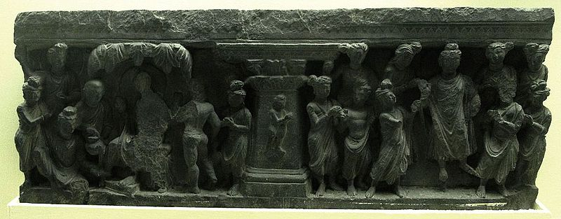**Ordination of Rahula**: source: Photograph from the [Indian Museum](https://en.wikipedia.org/wiki/Indian_Museum) in [West Bengal](https://en.wikipedia.org/wiki/West_Bengal) taken by [Anandajoti](https://commons.wikimedia.org/wiki/User:Anandajoti). Picture Courtesy: https://commons.wikimedia.org/wiki/User:Anandajoti

**▲ Prince Rāhula**

His father was Prince Siddhartha and mother was Princess Yasodhara. He was known as Rāhula Bhadda (lucky Rāhula) because he was fortunate to be the son of the Blessed One. Though his father prince Siddhartha left home to be an ascetic, legend says that Prince Rāhula had a comfortable life with his mother and grand-parents. The Vinaya Pitaka gives the following description of how prince Rāhula, was ordained at the age of seven.

*“…after staying at Rājagaha for as long as he liked, the Buddha set out wandering toward Kapilvatthu in the Sakyan country. When he eventually arrived, he stayed in the Banyan Tree Monastery. In the morning the Buddha robed up, took his bowl and robe, and went to Suddhodana the Sakyan’s house where he sat down on the prepared seat.*  *Queen, Yasodhara, mother of Rāhula, said to the boy*:

‘***This is your father, Rāhula. Go and*** *ask* ***for your inheritance.”***

*Rāhula went up to the Buddha, stood in front of him, and said*, *‘****Ascetic, your shadow is pleasant****.’ When the Buddha got up from his seat and left, Rāhula followed behind, saying:*

*“****Give me my inheritance! Give me my inheritance****!”*

*The Buddha said to Venerable Sāriputta:*

*‘****Well then, Sāriputta, give Rāhula the going forth****.’”* [27]

When King Suddhodana heard that his cherished grandson Rāhula had become a monk, he was overcome by sorrow. With a heavy heart the King went to see the Buddha and told him that there is no greater grief in this world than the loss of one’s “beloved children”.

“*When the Buddha went forth, it was very painful for me, and the same when Nanda went*

*forth. With Rāhula, it’s even worse. Affection for a child cut deep. It cuts through the outer*

*and inner skin; it cuts through the flesh, the sinews, and the bones, and it reaches all the*

*way to the bone-marrow. Please, may the venerable not give the going forth to a child*

*without the parents’ permission.”* [28]

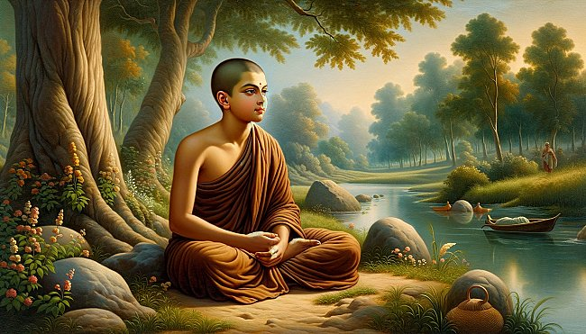

**Above: Artist’s impression of the young monk Rāhul**a, who followed the Blessed One’s training faithfully and dedicatedly from the age of 7 and became an arahant at the age of 21. Picture Courtesy: <https://www.originalbuddhas.com/blog>

Rāhula Thera’s mentor and teacher was Ven Sāriputta. A few years after his higher ordination, at age twenty-one, Rāhula Thera became an Arahant. The special event is described in the scriptures:

*“ …then, while the Blessed One was alone in meditation, a thought arose in his mind thus: “The states that ripen in deliverance have ripened in Rāhula. Suppose I were to lead him on further to the destruction of the taints… now on that occasion many thousands of deities followed the Blessed One, thinking: “Today the Blessed One will lead the venerable Rāhula further to the destruction of the taints”* [29]

**Note**: The commentary says: … those deities, who came from various celestial realms, had been companions of Rāhula’s during the previous life in which he first made the aspiration to attain arahantship as the son of a Buddha [30].

The Buddha declared Bhikkhu Rāhula as the foremost disciple among those desirous of training [31]

**In his Thera Gatha this is what the noble Rāhula Thera said:**

I am known as “Fortunate Rāhula”,

because I’m accomplished in both ways:

I am the son of the Buddha,

whose eye sees clearly in all things.

Having thrown off those sensual pleasures,

having cut Māra’s bond,

and having plucked out craving, root and all:

I’m cooled, quenched…” . [32]

**In his Thera Apadana the noble Rāhula Thera** mentioned his previous life and

encounter with the Buddha Padumuttura. The Blessed One foretold his future life that he will

become the son of Buddha Gotama:

“…Falling from Tusitā heaven,

incited by his wholesome roots,

he’ll be the legitimate son

of Gotama the Blessed One.

If he should remain in the house

then he would be a Wheel-Turner.

For that reason, an arahant can’t

obtain pleasure within the house.

Being well-trained he will renounce

after going forth from the house.

He will be known as Rāhula

and he will become an arahant.” [33]

**♦ The Buddha Guiding his Parents**

Above, we saw how the close relatives of the Buddha, having heard his teachings, established confidence in him and followed him to become liberated from all sufferings. Often, the Blessed One instructed his followers to respect and honour their parents as it is not easy to repay them. Hence, we thought it is appropriate to mention how the Blessed One paid his due to his parents and his foster mother.

The Buddha said:

*“…even if one were to establish one’s parents as the supreme lords and rulers over this great earth abounding in the seven treasures, one still would not have done enough for one’s parents, nor would one have repaid them. For what reason? Parents are of great help to their children; they bring them up, feed them, and show them the world… if, when one’s parents lack faith, one establishes them in faith… in virtuous behaviour… in generosity; … in wisdom: in such a way, one has done enough for one’s parents, repaid them, and done more than enough for them…”[34]*

♦ **How the Buddha taught his father and foster mother to understand Dhamma**

According to legend when the Buddha first visited Kapilavattu, he went out seeking alms from house to house. The king heard the news and was disturbed that the Buddha like a beggar going to houses form alms. Being a Sakyan and proud of kingship he rushed to the city met the Blessed One and asked the reason for doing such act. Out of compassion for the king, the Buddha said that receiving alms-food from door to door is a practice of all the Buddhas and his noble disciples.

*“…a bhikkhu, on receiving alms-food after standing with seemly propriety at the door of each donor, should be mindful of the receipt of the food; he should not receive or seek alms by improper manner…a bhikkhu, who cultivates the practice unfailingly in such a manner, will live in peace in this life…”*

At the end, the end the king was established in stream-entry (sotapatti) [35]. The same source mentioned that the next day the Blessed One, again stressed the importance of the Buddhas’ and his disciples to receive alms food properly, listening to the teaching the king became ‘anāgāmi’ (the 3rd noble stage) and queen Prajapati became a stream-winner. [36]

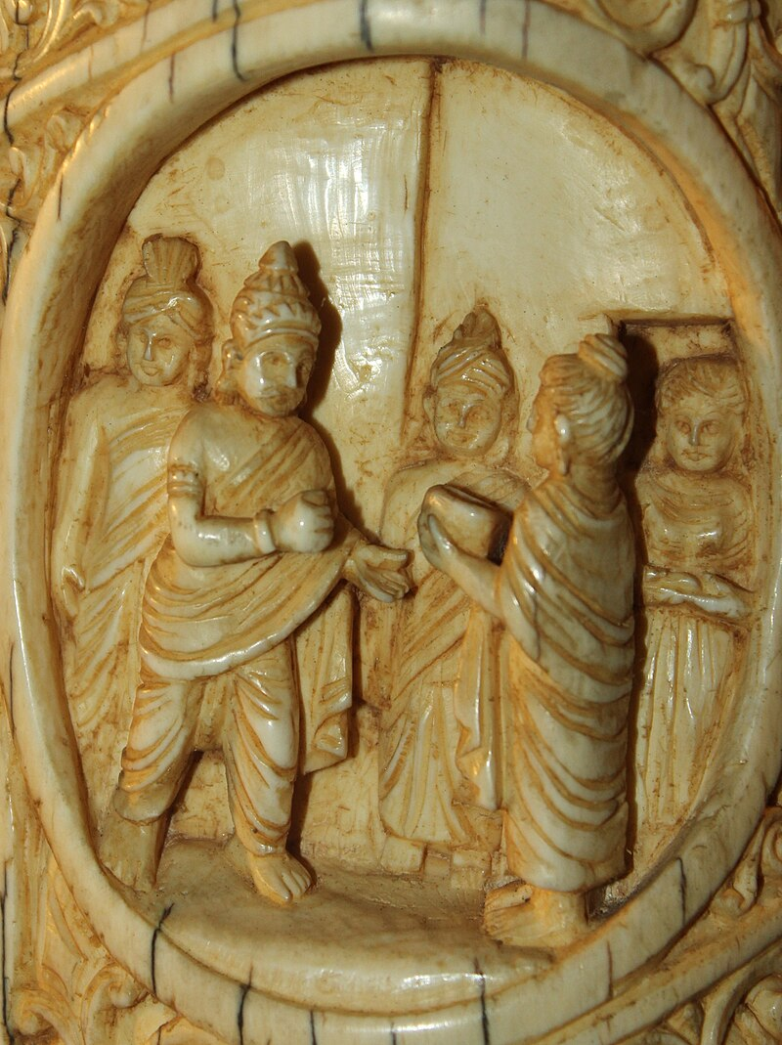

King Suddhodana meeting the Buddha in Kapilavattu

Source: [Author: Nomu420](https://commons.wikimedia.org/wiki/User:Nomu420)

Picture courtesy:

[User:Nomu420 - Wikimedia Commons](https://commons.wikimedia.org/wiki/User:Nomu420)

The Blessed One is said to have visited his father, King Suddhodana at his death-bed [37]The Buddha taught the Dhamma and the king became an arahant. He enjoyed the bliss of liberation for seven days as a lay person before passing away [38]

♦ **Helping** **Queen Prajapathi, the foster mother**

In Dakkinavibhnga sutta (MN:142) there is a passage pointing out how the Buddha helped his foster mother to establish in Dhamma. The following is a quote from Venerable Ãnanada:

*“…the Blessed One too has been very helpful to Mahāpajāpatī Gotamī, venerable sir. It is owing to the Blessed One that Mahāpajāpatī Gotamī has gone for refuge to the Buddha, the Dhamma, and the Sangha …it is owing to the Blessed One that Mahāpajāpatī Gotamī possesses unwavering confidence in the Buddha, the Dhamma, and the Sangha, and that she possesses the virtues loved by noble ones…”*

**Note:** * “ These are the four factors of stream-entry. Thus, it is clear that at the time this sutta takes place, Mahāpajāpatı̄ Gotamı̄ was already a stream-enterer”. [39]

* According to scriptures Bhikkhuni Maha Prajapati Gotami initiated the establishment of Bhikkhuni Sangha, became a great teacher an arahant [40]

In Their Gatha, Bhikkhuni Maha Prajapati Gotami paid her gratitude to the Buddha thus:

Since I have seen the Blessed One,

this bag of bones is my last.

Transmigration through births is finished,

now there’ll be no more future lives.

I see the disciples in harmony,

and resolute, always staunchly vigorous—

this is homage to the Buddhas!

It was truly for the benefit of many

that Māyā gave birth to Gotama.

He swept away the mass of suffering

for those stricken by sickness and death [41]

♦ **Establishing the mother who passed away and appeared in Deva Realm in Dhamma**

Queen Mahamaya, according to scriptures and legend was reborn in Tusita Deva Realm as young deva called Santusita (also called mother deva). The Buddha is said to have visited the

Deva world to deliver dhamma to his mother and other devas. Suntusita deva is said to have

become a stream enterer.

*“…the Buddha went to the Tāvatimsa deva world, his mother who had been reborn in*

*Tusita deva world as a deva known as Santusita also came to the Tāvatimsa deva world.*

*There the Buddha expounded the Abhidhamma to the devas and the brahmas throughout*

*the three months of the vassa (rain retreat period). As a* *result, Santusita deva attained sotāpatti fruition…”* [42]

**Note:** Earlier we saw a passage regarding queen Maya reborn in deva realm:

“*That’s so true, Ānanda! For the mothers of beings’ intent of awakening are short-*

*lived. Seven days after the being’s intent on awakening are born, their mothers pass away*

*and are reborn in the host of joyful gods… (tusita heaven) ”*

**See:** KN:Udana 5.2 Short lived sutta.

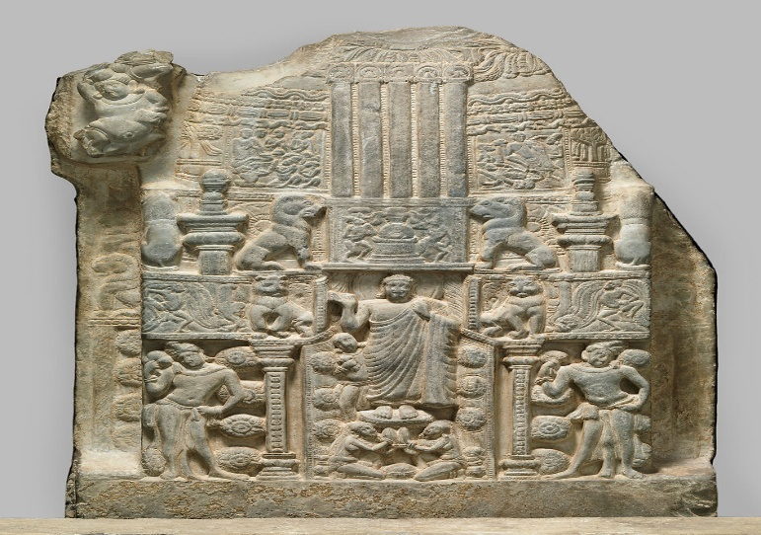

**The Blessed One coming from the Deva- loka** after teaching to his mother who was born as a young deva: Nagarjunakonda Stupa Site 6, Guntur district, Andhra Pradesh. Picture courtesy: https://www.metmuseum.org.

**◙ Summery**

* In here we saw a brief sketch of life of Buddha Gotama as child and a young man living a luxurious worldly life (age 1 -29) and his renunciation. Most of the information given here are gathered from scriptures, however, to elaborate certain points/events and to fill some gaps, we have taken some information from traditional Buddhist books and other sources which are documented in the End notes.

**\* Two important events** happened in this period may have imprinted in the mind of the future Buddha to let go of his princely life and to become an ascetic: 1) From his family and friends he may have heard of his future forecast by the brahmins on the day of his naming ceremony and pondered of what is better? To be a great king of wealth and power or to be an enlighten being and end all suffering? 2) the blissfulness experienced through the Samadhi as a child, the prince experienced may have brought pleasant and peaceful memories of solitude which may have grounded in his mind and may have surfaced in time to time-reminding the solace of peace in such life. Later in the compilation we can see how the memory of samadhi as child gave him insight to give up extreme ascetic practice and moved to the middle path.

* Since we were talking about the family of the Buddha, we thought it is appropriate at this juncture to mentioned some important things happened to his family members because of his enlightenment.

**End Notes: Section 2**

1. Naming ceremony is described in details see: Naming Ceremonies: The Great Chronicles of Buddhas by Venerable Mingun Sayadaw.
2. Tthe Blessed One said thus: “…my native place is Kapilavatthu, King Suddhodana is my father, my birth mother is Queen Maya…”, p, 264. This passage is translated from: Gotama Buddha Vamsa—Lineage of the Buddha Gotama: Buddha-Vamsa-Pali & Chariya Pitaka Pali: vol.38: Buddha Jayanti Publication.
3. Deah of Queen Maya and her appearance as a young deva in Tuista realm is described here. See: Death of Queen Maya: The Great Chronicles of Buddhas by Venerable Mingun Sayadaw.
4. In MN: Notes 1291 give information about Queen Mahapajapati becoming the foster mother of the Buddha.
5. **See**: DN:14 ( Mahâpadāna Sutta: The Great Discourse on the Lineage).
6. **See:** Ud.5.2 (Short lived sutta Translated by Bhikkhu Sujato, [www.Suttacentral.net](http://www.Suttacentral.net), for details see: MN: 123 (Wonderful and marvellous sutta) & AN:4: 127 (Astounding sutta).
7. Kāludāyi Thera as a lay person, was a son of one of King Suddhodana’s ministers, he had been a childhood playmate of the Buddha. He was sent by King Suddhodana to invite the Buddha, after his enlightenment, to return to Kapilavatthu. During the visit he inspired the Sakyans to have faith in the Buddha and was declared as the foremost in the Bhikkhu Sangha who inspire confidence in families: **see:** AN1:219 (Foremost)
8. **See:** Thag: 10.1 (Kāludāyi)
9. The Buddha declared Mahāpajāpatī Gotamī as the foremost of bhikkhunī disciples in seniority: see: AN1:235 (Foremost). For more details of Maha Prajapati: see: AN8: 51 (Gothami sutta), Thig: 66 & <https://dahampada.github.io/>
10. **See:** ThiAp: 7: (Maha Pajapati Gothami)
11. Detailed description of this event: see: The story of Kaladevala the hermit: The Great Chronicles of Buddhas by Venerable Mingun Sayadaw.
12. **See:** Snp: 3.11 (Nālaka sutta: translated from Pali by Bhikkhu Sujato, www.suttacentral net).
13. MN:36 (Mahāsaccaka Sutta). **Note:** The commentary (Majjima Nikaya Attakatha) says this:

    “…during the Bodhisatta’s boyhood as a prince, on one occasion his father led a ceremonial ploughing at a traditional festival of the Sakyans. The prince was brought to the festival and a place was prepared for him under a rose-apple tree. When his attendants left him to watch the ploughing ceremony, the prince, finding himself all alone, spontaneously sat up in the meditation posture and attained the first jhāna through mindfulness of breathing. When the attendants returned and found the boy seated in meditation, they reported this to the king, who came and bowed down in veneration to his son…’ **:** MN: Notes: 389, p.1101.
14. This passage is translated from: Gotama Buddha Vamsa—Lineage of the Buddha Gotama: Buddha-Vamsa-Pali & Chariya Pitaka Pali: vol.38: Buddha Jayanti Publication.

    This is mentioned in Buddhavamsa Pali- Chariya Pitaka: Linage of Buddha Gotama.
15. **See**: AN3:39.
16. For details see: The accession to the throne: The Great Chronicles of Buddhas by Venerable Mingun Sayadaw.
17. See: AN1: 243. *Yasodharā Theri is also known as -Baddakacchana, Bimba and Rāhula mātha (mother of Rāhula). * Mp identifies her as Rāhulamātā, the mother of Rāhula; hence she was the Buddha’s wife, better known in Buddhist tradition by the name Yasodharā, see: AN: Notes: 126.
18. **See**: ThiAp:28 (Yasodharā: Translated by Jonathan S. Walters.
19. See: Ud:3.2 (Translated by Bhikkhu Sujatho:www.suttacentral.net)
20. Ibid.
21. **Ibid.**
22. **See:** AN1:230* He was the Buddha’s half-brother, son of Suddhodana and Mahāpajāpati Gotamī. The story of how he left his fiancée to become a bhikkhu is told in Ud 3:2, 21–24. He is instructed by the Buddha at SN 21:8 and praised in AN at **8:9**. His verses are at Th 157–58, see: AN:Note:111.
23. Thag:2.19 (Nanda: translated by Bhikkhu Sujato: www.suttacentral.net.)
24. ThaAp:1.13 ( translated by Bhikkhu Sujato: www.suttacentral.net.)*Details regarding Nanda Thera see: <https://dahampada.github.io/>
25. AN1:240 * Also known as Sundarīnandā because of her beauty, she was the Buddha’s half-sister and the full sister of Nanda. Her story is in Nyanaponika and Hecker 2003: 282–85. She has verses at Thī 82–86, see: AN: Notes: 121.
26. Thig:2.19 (Translated by Bhikkhu Sujato: w.w.w.suttacentral. net.)
27. **See:** VP: Mahākhandhaka:41 Rahula’s story: Theravāda Collection on Monastic Law: A translation of the Pali Vinaya Piţaka into English by Bhikkhu Brahmali.
28. Ibid. Note: According to Vinaya Pitaka this incident led to the rule: the permission of parents required for ordination of a son/daughter.
29. **See**: MN :147 (Cūḷarāhulovāda Sutta)
30. MN: Notes: 1325, p. 1184: says that: those many thousands of deities who were present at this discourse became noble ones. For details regarding Rāhula Thera see: <https://dahampada.github.io/>
31. AN1:209 * The Buddha’s son. His first encounter with his father, when he was seven, is related at Vin I 82,8–31. The Buddha addresses the following discourses to him: MN 61, MN 62, MN 147; SN 18:1–22; SN 22:91–92; SN 35:121 (= MN 147); and Sn 2:11, **See:** AN: Note:92.
32. Thag: 4. ( Rāhula Translated by Bhikkhu Sujato: w.w.w.suttacentral.net.)
33. ThaAp:16 (Rāhula Translated by Jonathan S. Walters)
34. **See:** AN2: 33.
35. See: King Suddhodana attaining the first path & 3rd path: The Great Chronicles of Buddhas by Venerable Mingun Sayadaw.
36. Ibid.
37. About King Suddhodhana becoming an arahant: In Thī-a 3, [the commentator] Dhammapāla says, ‘He had the young Nanda and the young Rāhula go forth and then the Teacher returned again to Rājagaha. On a later occasion, when the Teacher was living in the Kūṭāgāra Hall near Vesālī, the great King Suddhodana attained final quenching [nibbāna], having realized arahantship even while he was still [reigning] under the white parasol. The inclination to go forth arose in Mahā-Pajāpatī’ (Pruitt 1998: 6–7). This is also given at Thī-a 141 (Pruitt 1998: 181). King Suddhodana is the only layman I know of who became an arahant and remained a layman, which means he could not have lived more than seven days after becoming an arahant.”see: AN: Notes: 1731.
38. See: King Suddhodana attaining the first path & 3rd path: The Great Chronicles of Buddhas by Venerable Mingun Sayadaw.
39. See MN: Note: 1293.
40. See: AN:8: 51. It says that she ordained with 500 sakyan ladies.
41. Thig:6.6 (Translated by Bhikkhu Sujato: w.w.w.suttacentral.net.)
42. **See**: Dhp: 14.2 . * The story of the Buddha’s return from the Tāvatimsa Deva world, see: Illustrated Dhammapada: Ven.Weragoda Sarada Maha Thero.